Dear Parents and Carers 20th March 2020

URGENT – FOR PARENTS WHO IDENTIFY AS KEY WORKERS. RESPONSE NEEDED BY 3.00PM TODAY

I will be writing a more detailed letter to you later today, which will try to cover all the latest developments re GCSE and A level exams and a reminder about how we will be working with your sons and daughters over the coming weeks.

For now, and most urgently, I need you to read the following carefully.

Just after midnight, the list of Key Workers was released to the public. https://www.gov.uk/government/publications/coronavirus-covid-19-maintaining-educational-provision/guidance-for-schools-colleges-and-local-authorities-on-maintaining-educational-provision

Whilst recognising there is a case for most people on that list to be included, it actually puts me and the school in a virtually impossible situation. Whilst not knowing exactly how many of our parents fall in to those categories, I already know that we will not be able to meet the likely demand.

As you will also be aware, we have carefully planned the work of students and our teachers, who will be working from home, remaining in close contact with their classes each day. As such, I have a tiny number of staff available to work with any other children in school, some of whom are vulnerable themselves. Should they themselves contract the virus, or have to self-isolate, then I will have to close the school outright.

Even if you belong to any of the groups highlighted in the above document, I urge you, most strongly, to make arrangements for your child to stay at home throughout the coming weeks. The chances of transmission of coronavirus are significantly raised if children remain in school, possibly endangering the lives of loved ones back home and my staff here in school.

I understand this may cause you difficulty. Many of my own staff are in similar situations, having to make considerable sacrifices also. Nonetheless I again urge you to please make arrangements for your child to stay at home, and carry out the social distancing and isolation necessary to help slow the spread of this disease.

If, having read the above, you feel it necessary to request to send your child to school from Monday and you are deemed to be a Key Worker, please fill in the enclosed form and email it back to vmckeen@sirgrahambalfour.staffs.sch.uk to register your child’s name, your contact number, and the nature of your role as Key Worker and other details. Please do this by 3.00pm today, Friday 20th March, in order that I can let you know what the likely situation will be.

Depending on the numbers of requests I receive, I must tell you that I may have to prioritise the children we can take in, in order to balance safety and safeguarding for all, with the number of staff I may have available. This would be done in conjunction with our LGB: I wish to make it clear that we would prioritise the children of front-line NHS staff before any others.

I thank you for your ongoing understanding at this very difficult time for all of our school community.

Yours faithfully
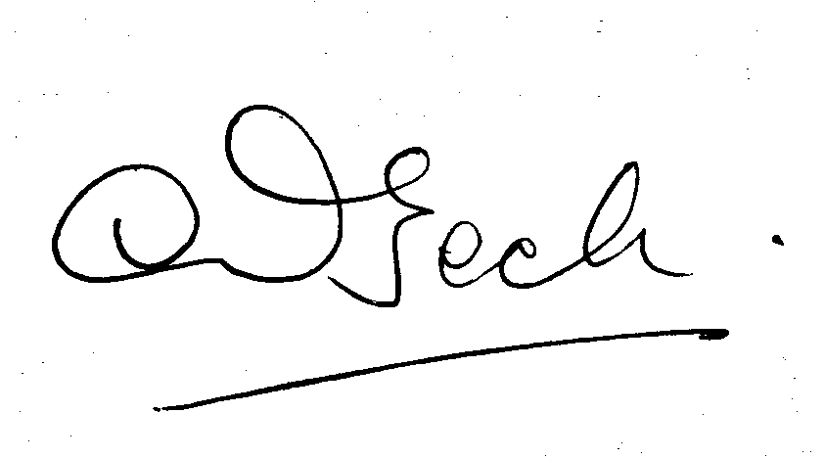
Mrs L Beck
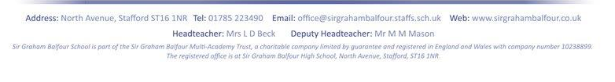
Headteacher

Key Workers Registration Form

Please complete one form per child.

Name of Child:

Date of Birth: |  | Year Group:
Name of Key Worker
Parent (s):
Job Title:

Place of Work (inc. dept
if applicable
Work Address & Phone
Number:

Emergency Contact Details (we will only use this in an emergency)

Name of Person:
(if not named above)
Emergency Number
Work:
Emergency Number
Mobile:

Food Requirements:  Please indicate from the  options your choice: | We are working to see if we can offer any facility for food provision at lunch time; please indicate if you would want your child to eat from a very limited range available or if you will be providing lunch from home.  Limited range from school (not currently guaranteed to be available)  Lunch from home
COVID-19 Agreement | I understand the need for self-isolation and following government guidelines. If my child or any one in my household has symptoms of the Coronavirus I will not send them into school for 14 days.
Availability Agreement | I understand that there is no guarantee that Sir Graham Balfour can or will remain open and that I will therefore have to make alternative arrangements for my child if the school is forced to close due to staff shortages.
Signed

